SCHOOL OF INNOVATION AND MANAGEMENT (SoIM)

INDUSTRIAL VISIT REPORT
Green Gold Animation Pvt. Ltd., Hyderabad
Corporate Immersion Program | Media & Entertainment
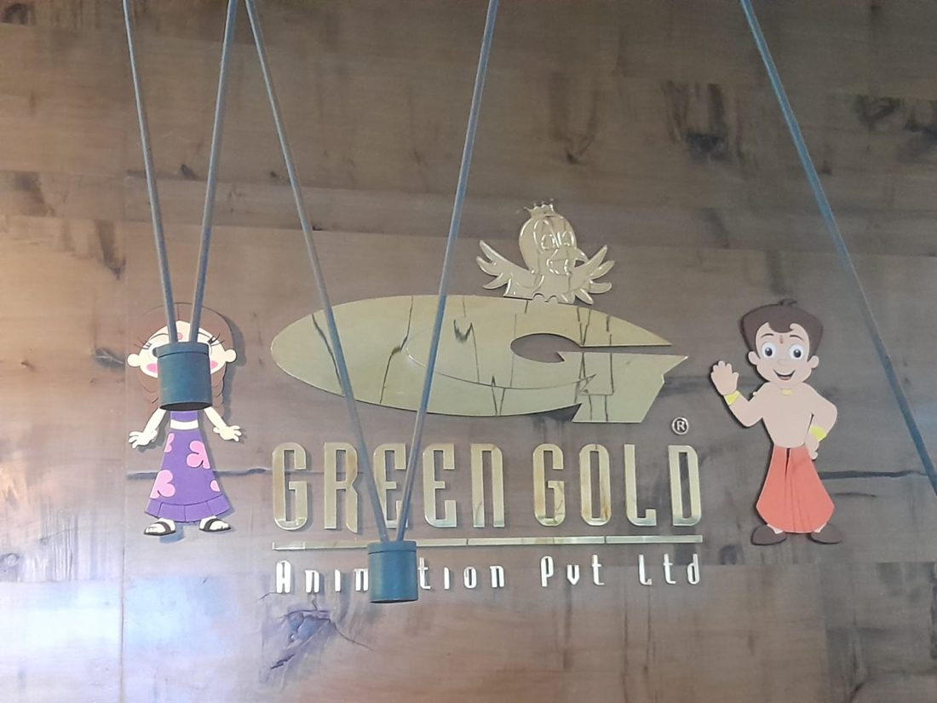
Green Gold Animation Pvt. Ltd. – reception wall with Chhota Bheem and Chutki
Date of Visit: 29 September 2026
Location: Hyderabad, Telangana
Submitted by | Gnaneshwari Mahimaluru
Roll / Registration No. | PGBA25005
Programme | Post Graduation Diploma in Management – Business Analytics
Institute | School of Innovation and Management
Faculty Coordinator | Dr. L. K. Revathi

Acknowledgement
I express my sincere gratitude to the management and team of Green Gold Animation Pvt. Ltd. for hosting us and for the informative sessions on animation production, digital business and the media and entertainment value chain. I especially thank Mr. Surya S, Senior Manager – Content Sales, for the session on how stories become businesses.
I also thank our institute and faculty coordinators for organising this Corporate Immersion Program, which gave us first-hand exposure to a leading company in the Indian animation industry.

1. Introduction
The Corporate Immersion Program aims to give students first-hand exposure to the corporate environment, to acquaint them with industry practices and to help them understand how a leading organisation functions. As part of this program, a visit to Green Gold Animation Pvt. Ltd. was held on 29 September 2026.
The visit combined a studio tour with presentations on the company, its 2D and 3D production work, its digital business and the wider media and entertainment industry.

1.1 Objectives of the visit
- To observe how an animation studio works, from concept to final delivery.
- To understand how characters become Intellectual Property (IP) and sustainable businesses.
- To learn how digital platforms such as YouTube and OTT services drive reach and revenue.
- To explore career paths in the creative, business, marketing and technology sides of the industry.
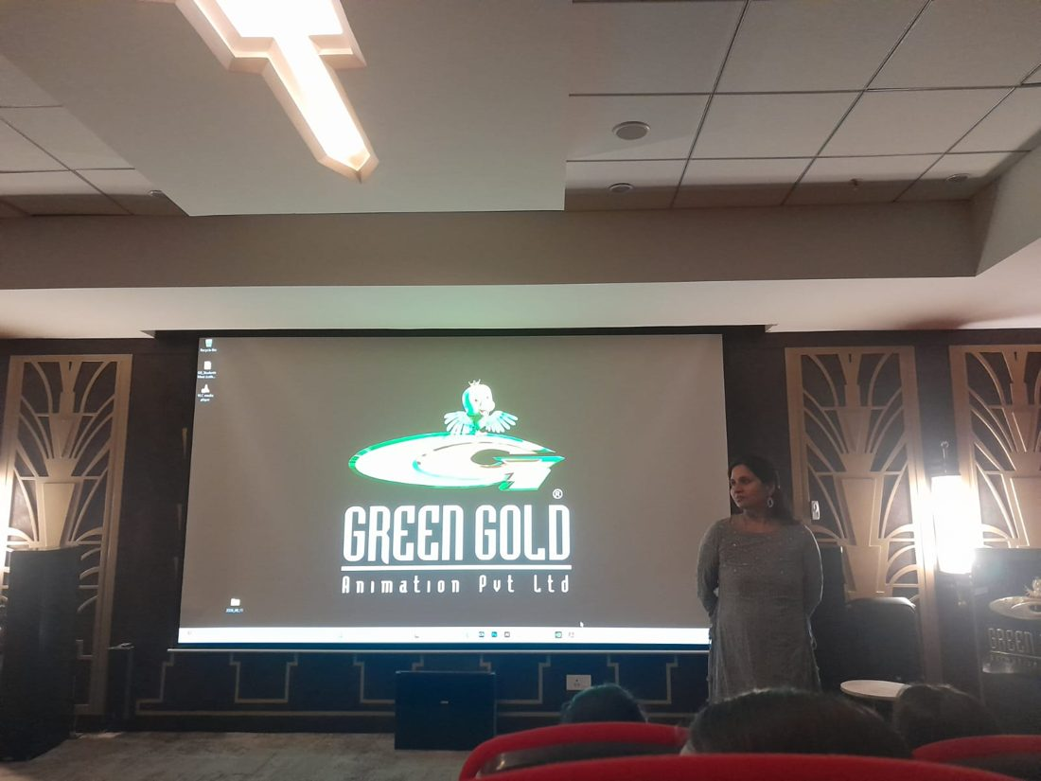
Figure 1: Company introduction session at the studio auditorium

2. Company Profile
Green Gold Animation is a pioneer in Indian animation and an IP studio based in Hyderabad, Telangana. It was founded in 2001 by Rajiv Chilaka. Its first big milestone shown in the presentation was Krishna: The Birth, which premiered on Cartoon Network on 16 August 2006.
Company | Green Gold Animation Pvt. Ltd.
Headquarters | Hyderabad, Telangana, India
Founded | 2001, by Rajiv Chilaka
Business | Animation production, IP creation and licensing, digital content, merchandise
Key IPs | Chhota Bheem, Mighty Little Bheem, Mighty Raju, Super Bheem, Krishna, Luv Kushh, Kalari Kids, Arjun, Chorr Police, Vikram Betaal, Super Chhota Startup
Official YouTube | Green Gold TV – 2.22 crore subscribers, about 3.5K videos

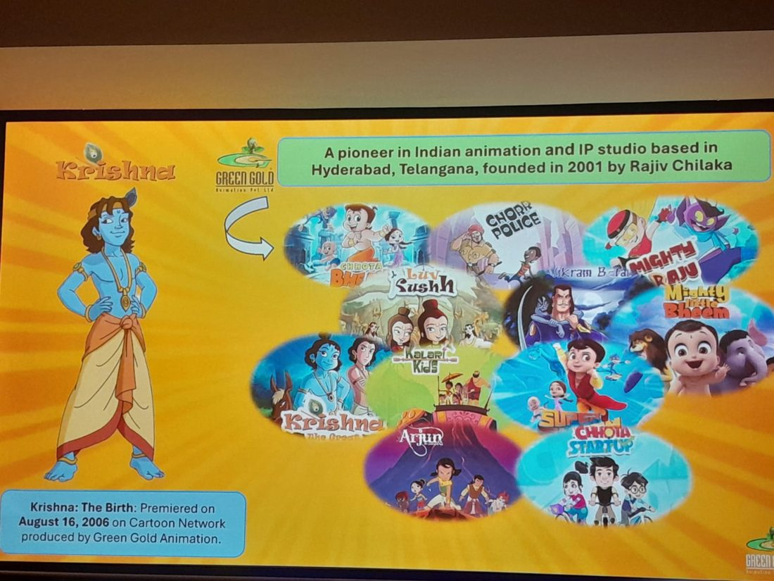
Figure 2: Green Gold Animation – founding details and key IP portfolio
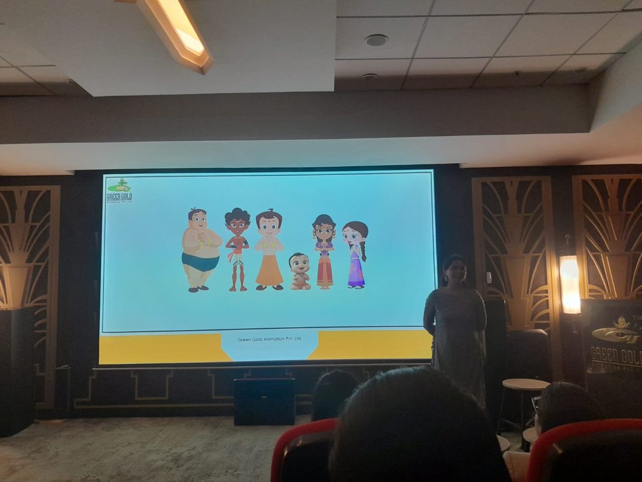
Figure 3: Chhota Bheem and his friends

2.1 Global reach: Mighty Little Bheem
Mighty Little Bheem was presented as an Indian IP that travelled globally. It runs as a Netflix series, and on the Netflix Jr. YouTube channel (about 26.4 million subscribers) its clips are among the most viewed, with the top videos shown at roughly 1.1 billion, 757 million and 711 million views.
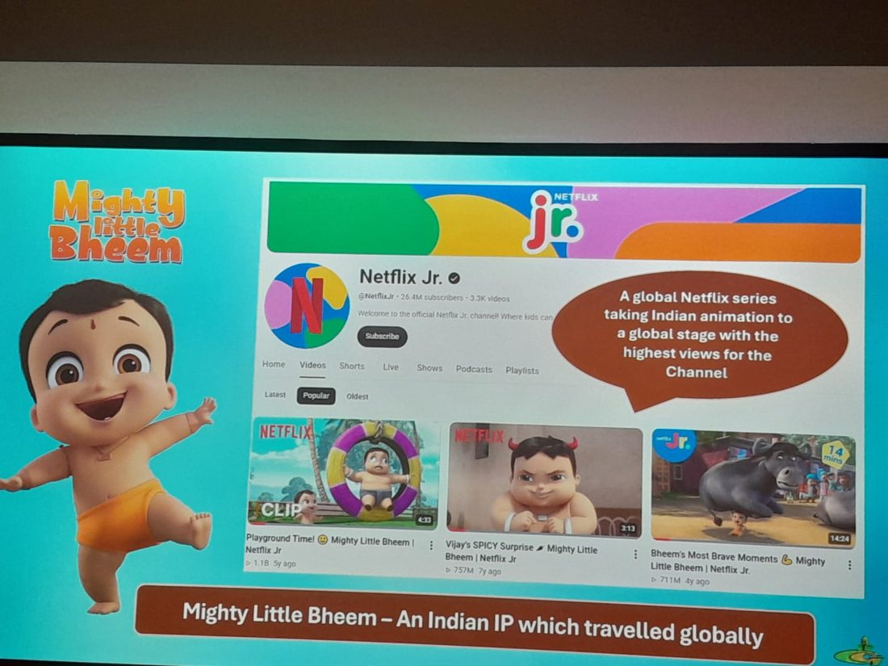
Figure 4: Mighty Little Bheem on the Netflix Jr. channel

2.2 Clients and partners
The presentation showed a wide list of brand partners and broadcast or platform clients. Brand partners included Parle-G, Usha, Cadbury, Savlon, Cello, Britannia, Kellogg's, ICICI Bank, Classmate, Rasna, Reliance Trends, HP, Funskool, Milton and Patanjali. Platform and broadcast clients included Netflix, Disney, Turner, Amazon Prime Video, YouTube, Viacom18, Jio, Astro and Moonbug.
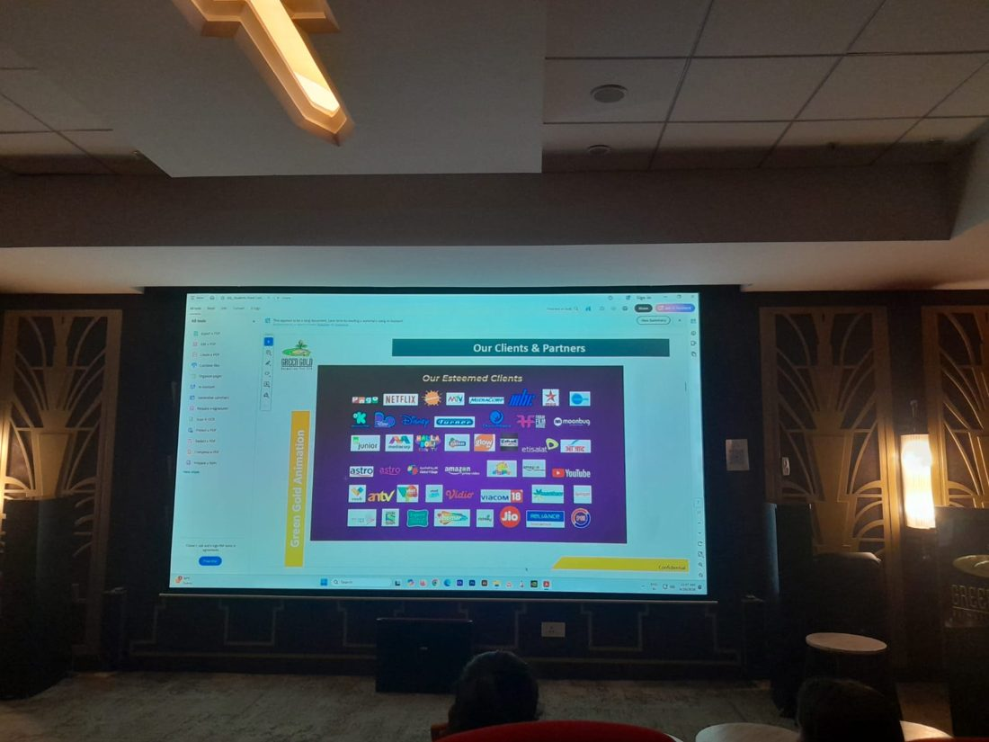  Figure 5: Brand clients and partners | 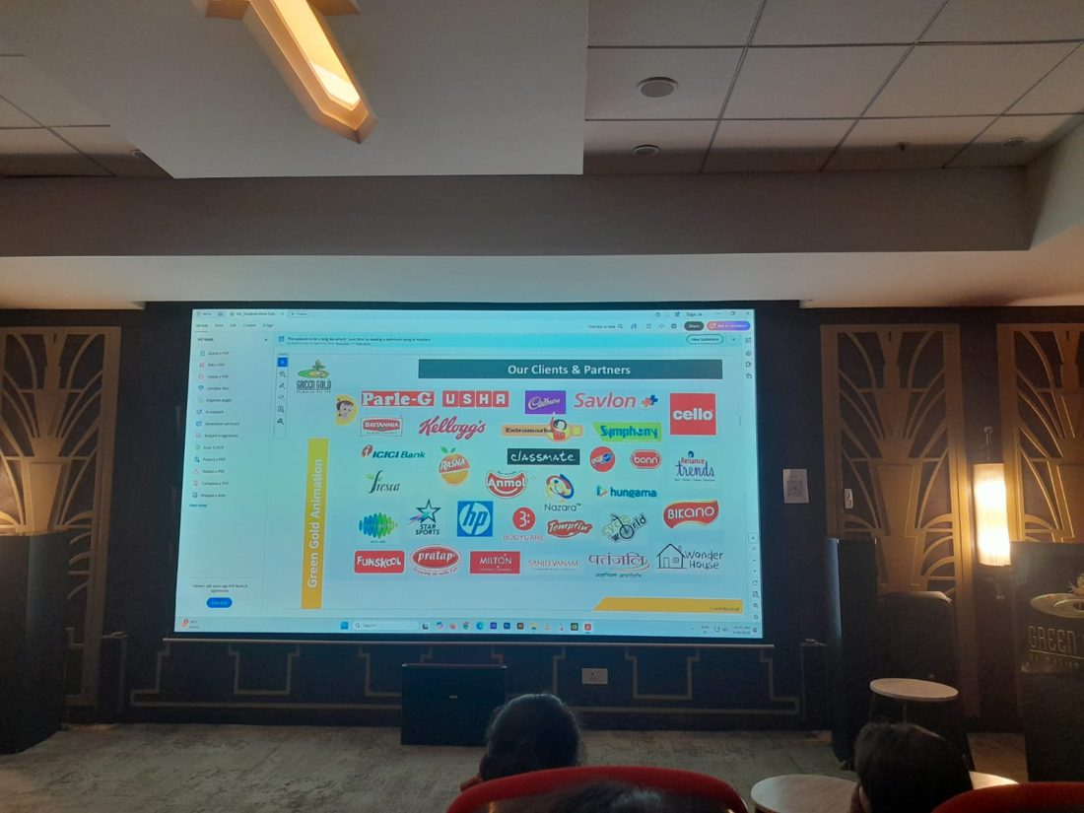  Figure 6: Platform and broadcast clients

3. Animation Production
The team shared current 2D and 3D work samples, including title songs and episodes from the Chhota Bheem franchise, original 2D shows and Mighty Little Bheem content.
Type | Work samples showcased
2D | Chhota Bheem – Bheemayan title song; Gadadhari Bheem title song; Originals – Chor Chor, Munna Autowala and Teen Buddhu; 2D process flow
3D | Chhota Bheem – Shakti Asta Ka Khoj; Aag Aur Pani Ki Takkar title song; Mighty Little Bheem and MLB Play Time; MLB Making Team

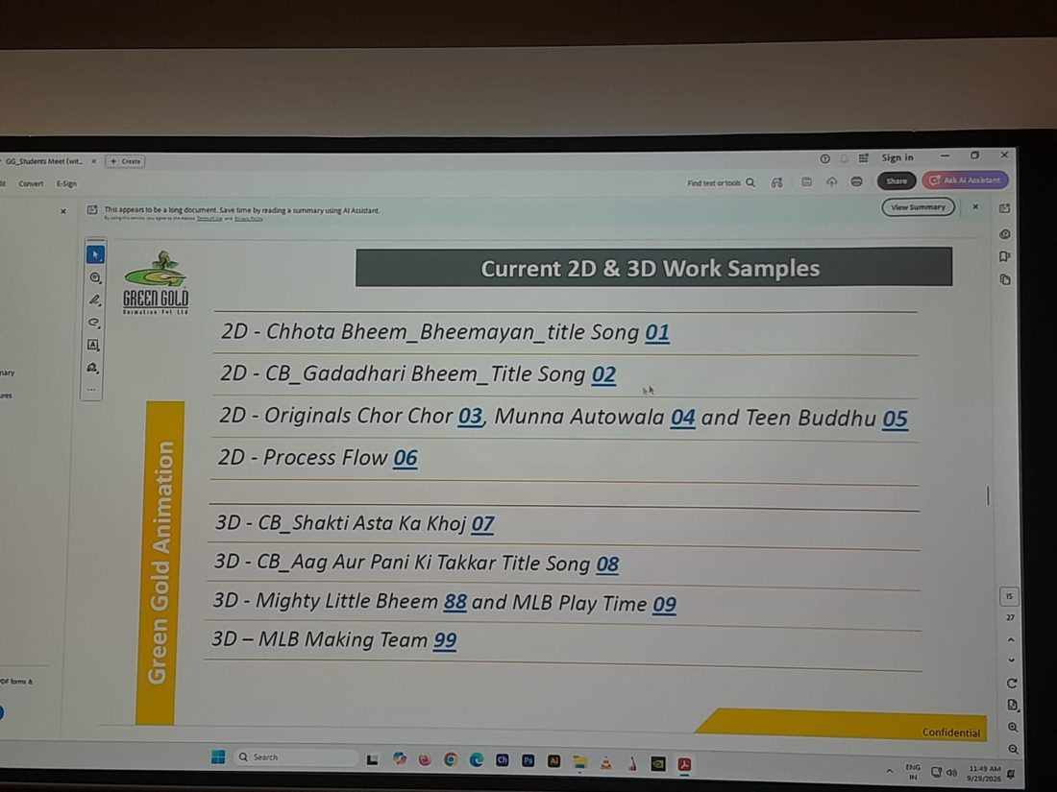
Figure 7: Current 2D and 3D work samples

3.1 The 2D production process
Green Gold explained its 2D pipeline as a linear flow in which each stage has a dedicated team:
No. | Stage | What happens
1 | Script | Story and dialogue are finalised.
2 | 1st sound dubbing | Voice recording that guides the timing of the animation.
3 | 2D inputs | Character design, layout concept and props design.
4 | Storyboard | The script is turned into a shot-by-shot visual plan.
5 | 2D layout | Scene composition and camera framing.
6 | Digital pre-production | Colouring, rigging and scene building.
7 | Root BG colouring | Background artwork is coloured.
8 | Animation | Characters are animated in the scenes.
9 | Post-production | Compositing, 2D effects and editing.
10 | Mixing | Sound effects, music mixing, final dubbing and final mix.
11 | Final quality check | Review for errors before delivery.
12 | Final rendering and upload | The episode is rendered and uploaded for release.

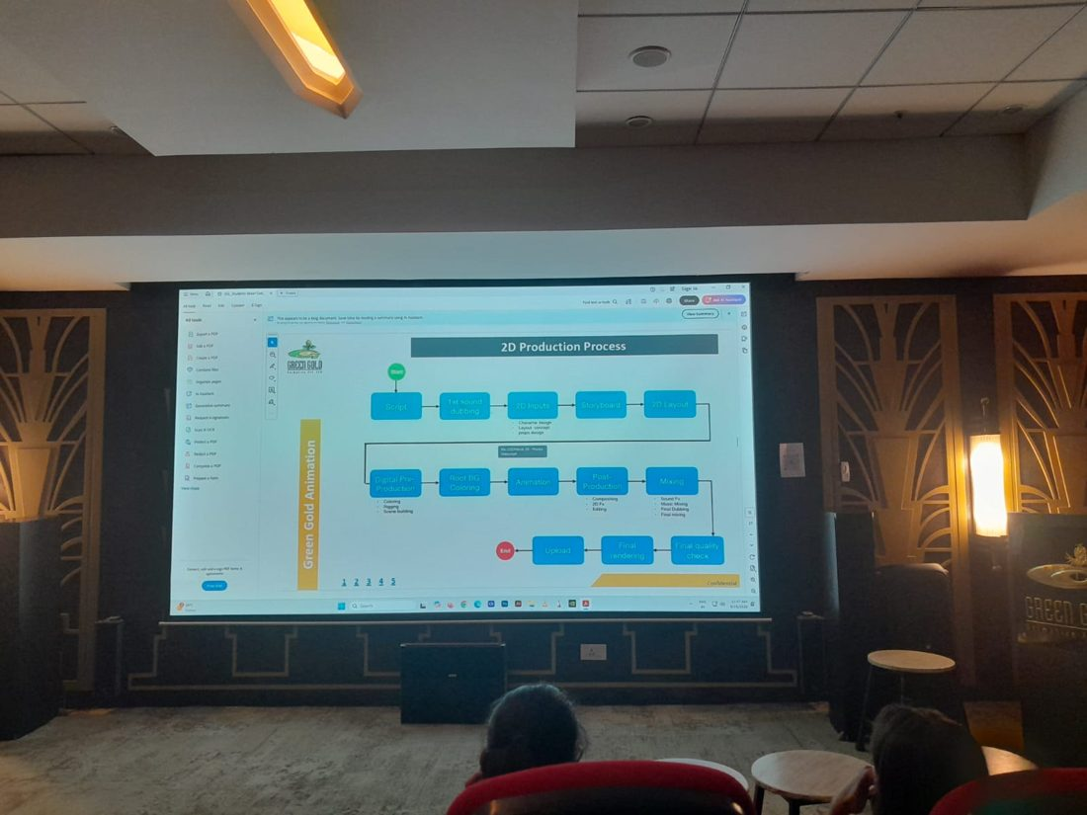
Figure 8: 2D production process flowchart presented by the studio

3.2 The 3D production pipeline
Green Gold also produces 3D content such as Mighty Little Bheem. A 3D pipeline generally moves through the following stages:
- Pre-production: script, concept art, character and environment design, storyboard and animatic.
- Modelling and texturing: building characters, props and sets in 3D and giving them surfaces and colour.
- Rigging: creating the digital skeleton and controls so that characters can move.
- Layout and animation: camera setup, scene blocking and performance animation.
- Lighting and rendering: setting lights and generating the final image frames.
- Compositing and post-production: combining layers, effects, colour correction, sound and music.
- Quality check and delivery: final review and upload.

4. Digital Business
A dedicated session covered how Green Gold runs its digital business. The company treats digital as a two-way channel: audience insights show what works and where content can improve. The session listed what makes Green Gold unique online:
- A strong digital presence built on two-way communication, using audience insights to improve.
- Unique thumbnails compared with other popular Indian characters on YouTube.
- Songs available on all the major music platforms.
- Separate YouTube channels for popular characters such as Chutki, Kalia, Mighty Raju, Super Bheem and Krishna.
- Chhota Bheem games and exclusive merchandise.
- The highest number of Instagram followers for any kids' character in India.
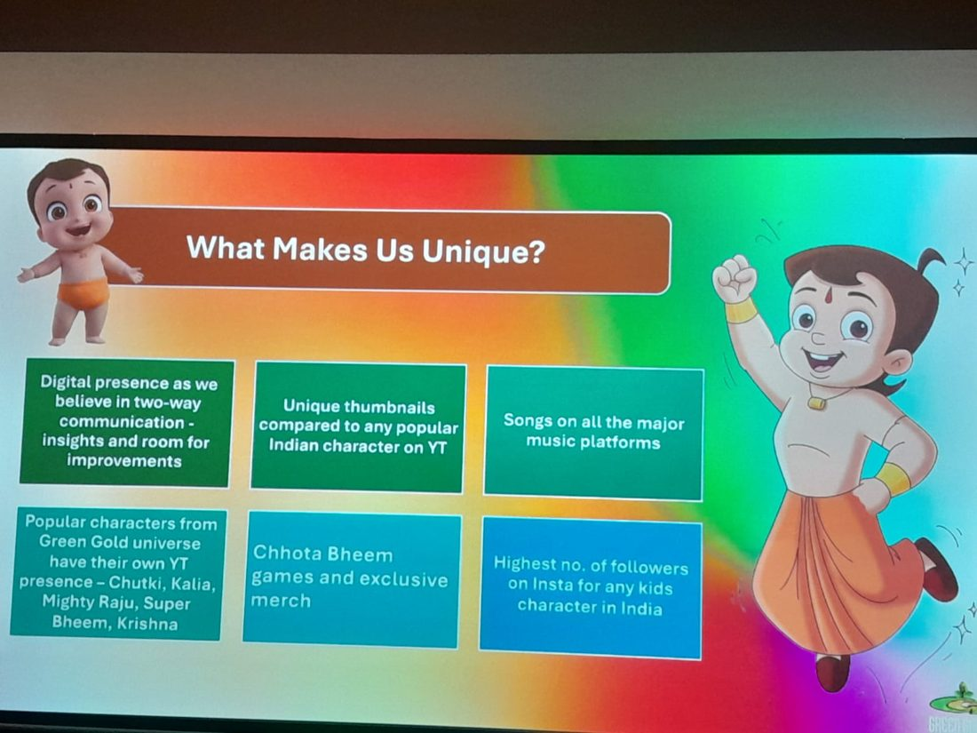  Figure 9: What makes Green Gold unique | 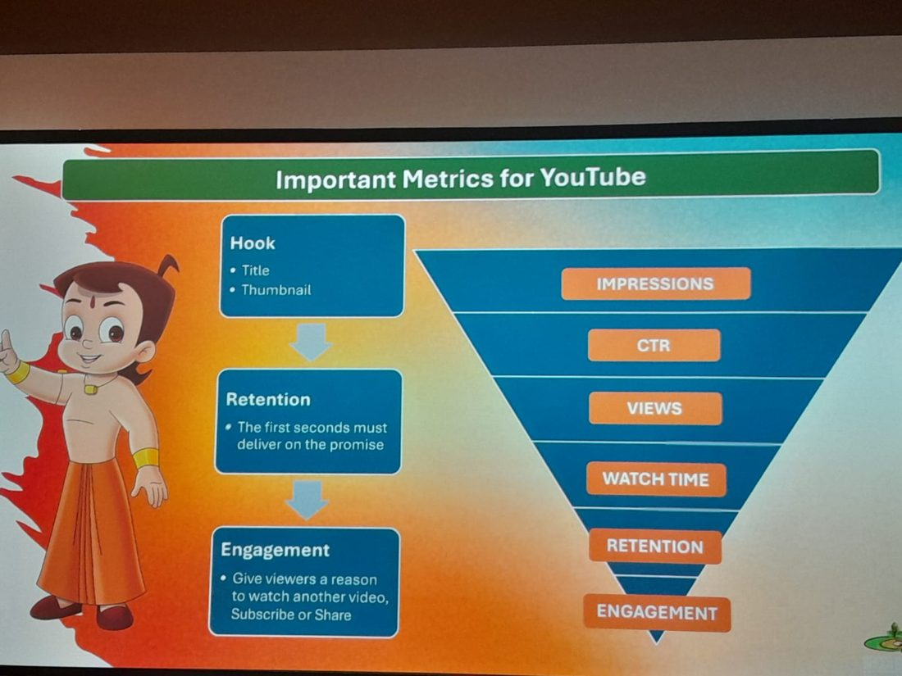  Figure 10: Important YouTube metrics

4.1 Important YouTube metrics
The session explained YouTube performance as a funnel, moving from Impressions to CTR, Views, Watch Time, Retention and Engagement. Three ideas sit behind it:
- Hook: the title and thumbnail must win the click.
- Retention: the first seconds must deliver on the promise made by the hook.
- Engagement: viewers need a reason to watch another video, subscribe or share.

4.2 One character, different audiences
The same character can serve different audiences: the child wants fun, adventure, jokes and heroes; the parent looks for trust, safety, value and convenience; and the young adult may respond to nostalgia and shareability.

5. Media & Entertainment: How Stories Become Businesses
Mr. Surya S, Senior Manager – Content Sales, presented a session covering strategy, brands, marketing, content and IP.
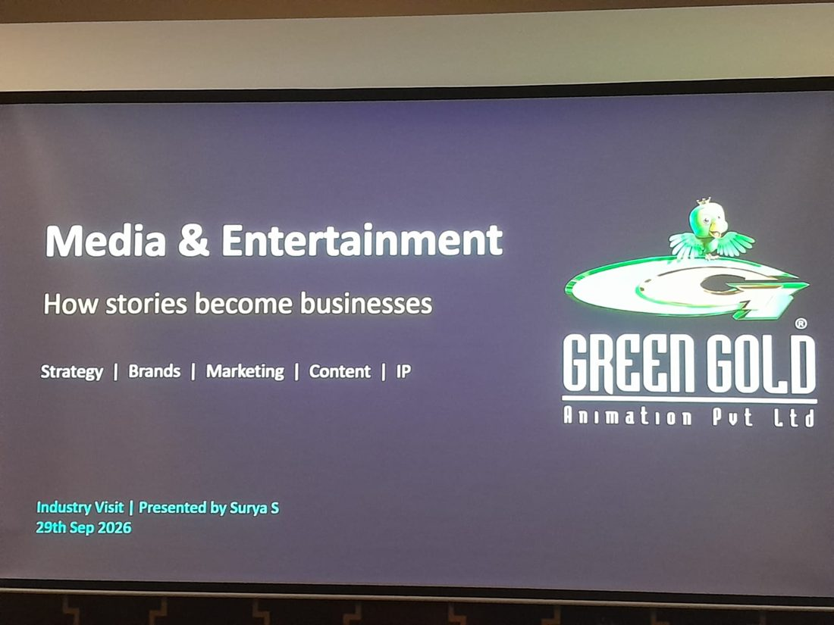  Figure 11: Session title slide | 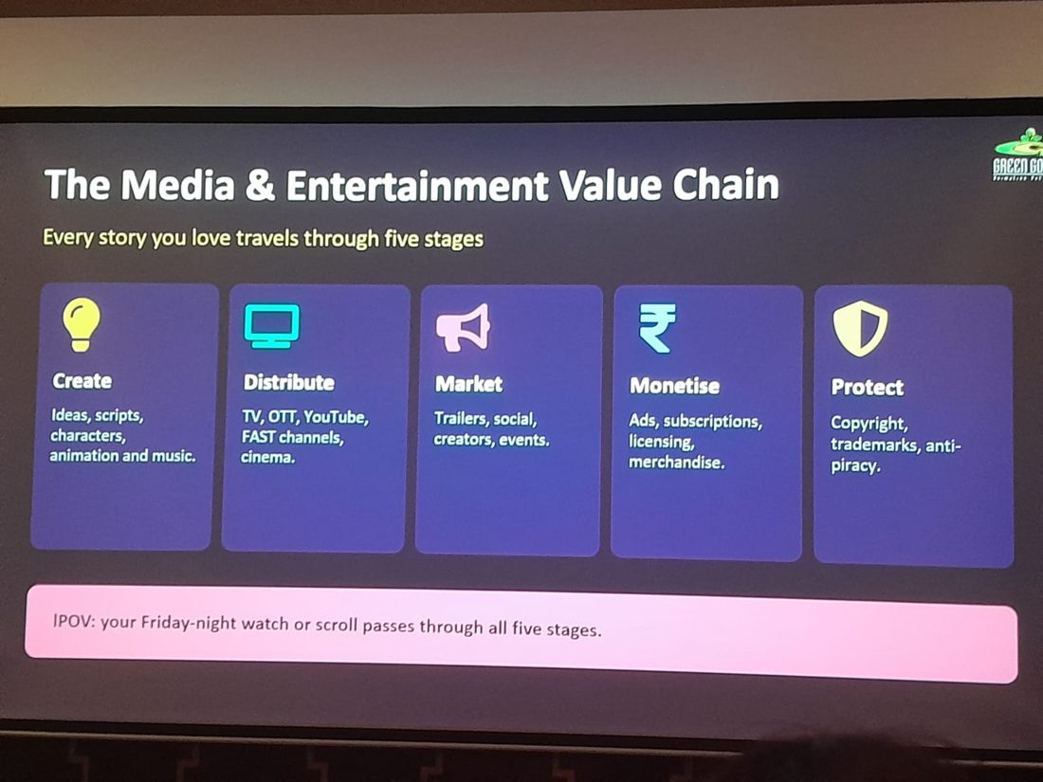  Figure 12: The M&E value chain

5.1 The value chain
Every story travels through five stages: Create (ideas, scripts, characters, animation and music), Distribute (TV, OTT, YouTube, FAST channels and cinema), Market (trailers, social media, creators and events), Monetise (ads, subscriptions, licensing and merchandise) and Protect (copyright, trademarks and anti-piracy).

5.2 Business strategy
The core message was that one show is never just one show. The four principles were to build the IP and not just the episode; go where the audience is by selling across territories and platforms such as broadcasters, SVOD, FAST and YouTube; partner to scale through co-productions and licensing that share cost and risk; and diversify revenue so that no single platform or deal carries the business.

5.3 Brand management
A brand is a promise people can feel. Bheem stands for courage and friendship, and every story and product must fit that personality. Other principles were consistency across screen, merchandise and social media, protecting the trust of parents, platforms and partners, and refreshing formats without losing the brand's core.
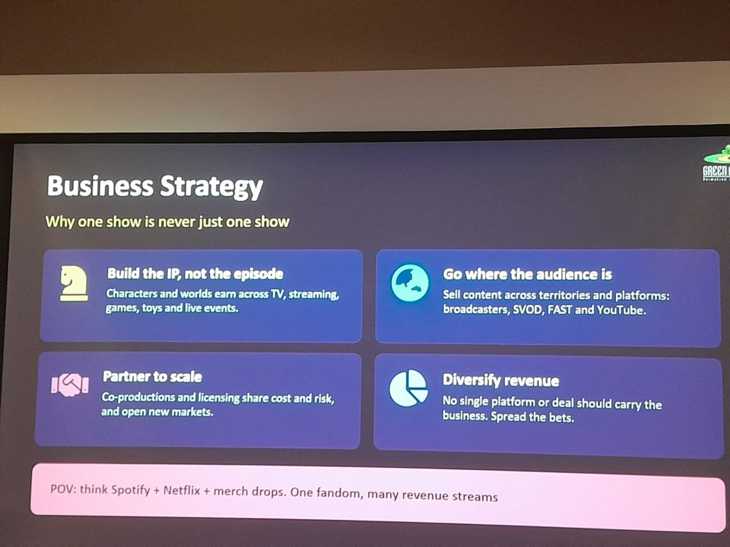  Figure 13: Business strategy | 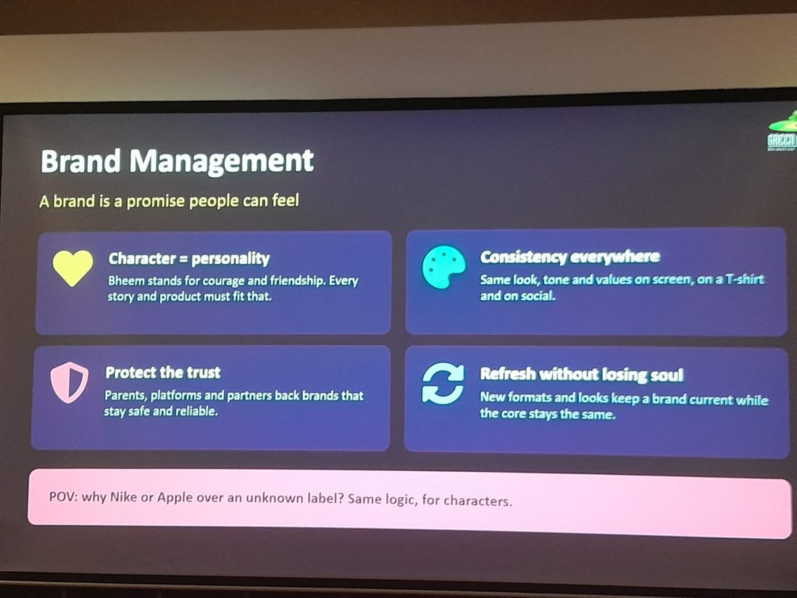  Figure 14: Brand management

5.4 Intellectual property
IP covers the characters, stories, music and designs that a creator legally owns. Rights are licensable, since territory, platform, duration and exclusivity can each be sold separately. IP is protected through copyright, trademarks and anti-piracy work, and monetised through licensing, merchandise, publishing and co-productions.

5.5 Content creation
Content moves from idea and story (audience research, a strong hook and characters people root for) to design and animation (scripts, storyboards, character design, animation, sound and music). Localisation through dubbing and adaptation multiplies reach. New tools and AI speed up production, but taste, story and direction stay human.
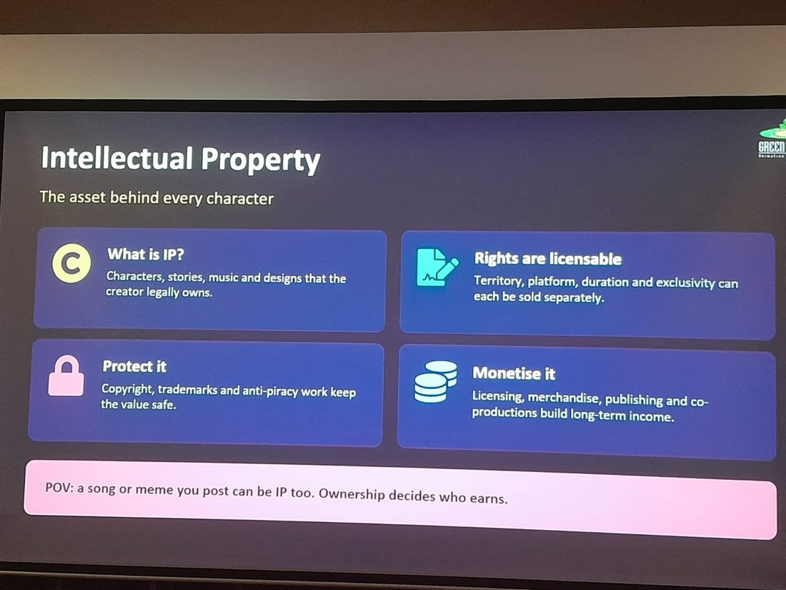  Figure 15: Intellectual property | 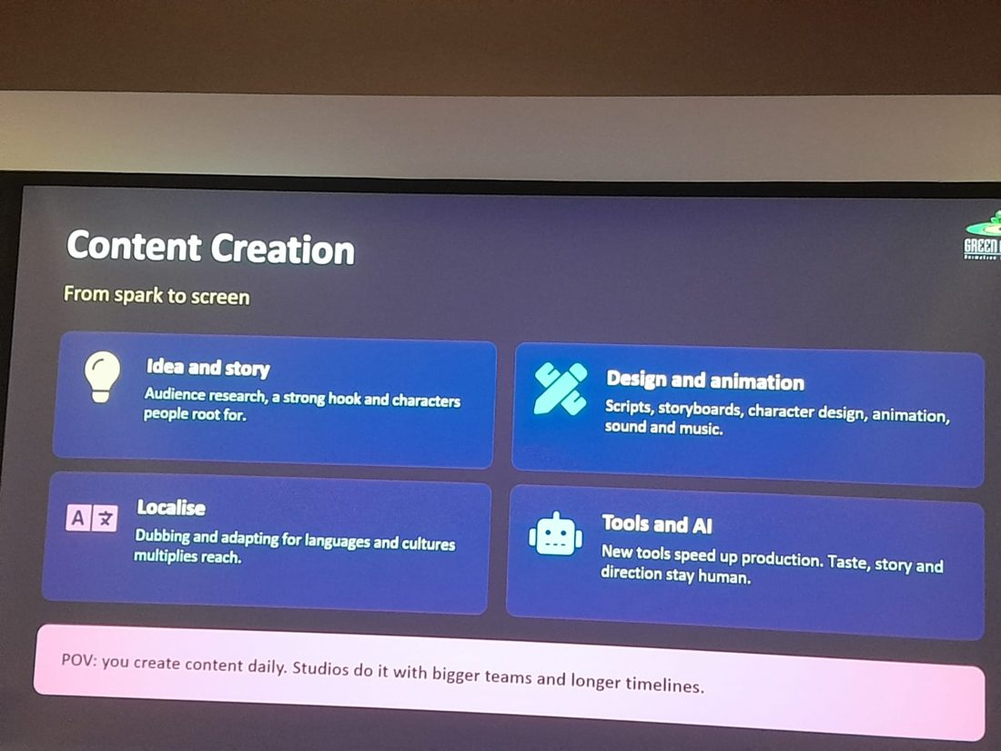  Figure 16: Content creation

5.6 Marketing
Attention is the currency. The session highlighted meeting fans on their feeds through reels, shorts and memes; building community through fan edits and challenges; making data-led decisions using views, watch time and search trends; and timing campaigns around festivals, releases and trending moments. Nostalgia was described as a growth hack, since childhood cartoons keep returning as memes.

5.7 Careers in the industry
Area | Roles
Creative | Writers, designers, animators, directors, sound and music
Business | Content sales, licensing, partnerships, finance, legal
Marketing | Brand, social media, community, analytics
Tech | Pipeline tools, streaming, data, AI and VFX tech

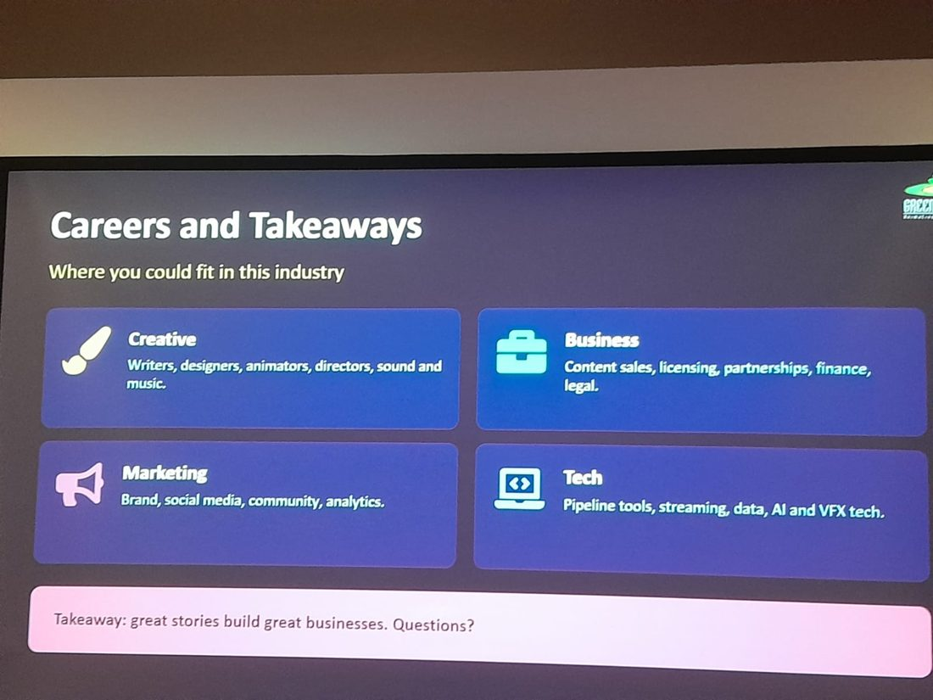
Figure 17: Careers and takeaways
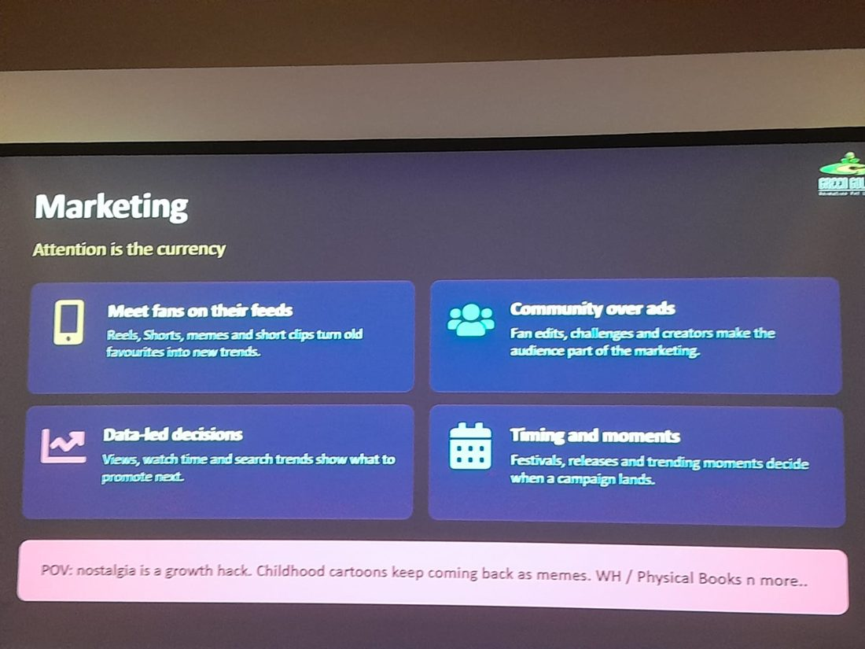
Figure 18: Marketing – attention is the currency

6. Studio Tour
The visit included a walk through the reception and lounge areas, which display life-size figures of Green Gold's characters, including Chhota Bheem, Kalia, Chutki, Mighty Raju and a model of Mighty Little Bheem. The space reflects how strongly the company builds its brand around its characters.
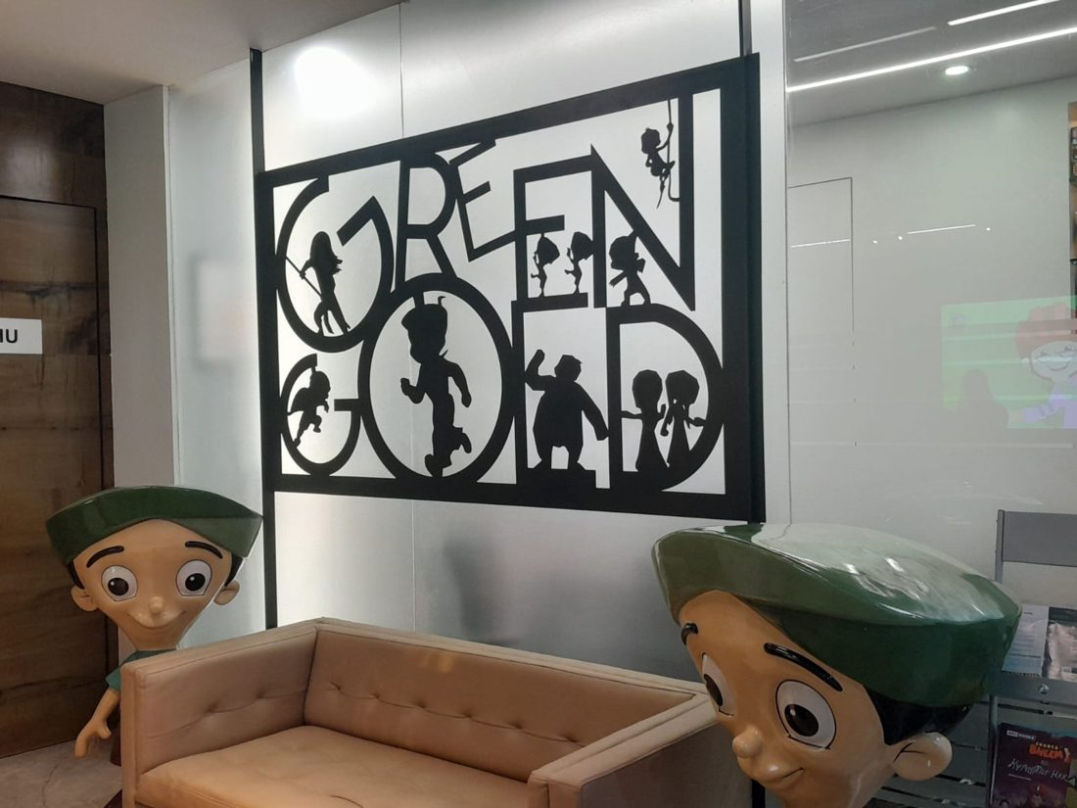  Figure 19: Green Gold signage with character silhouettes | 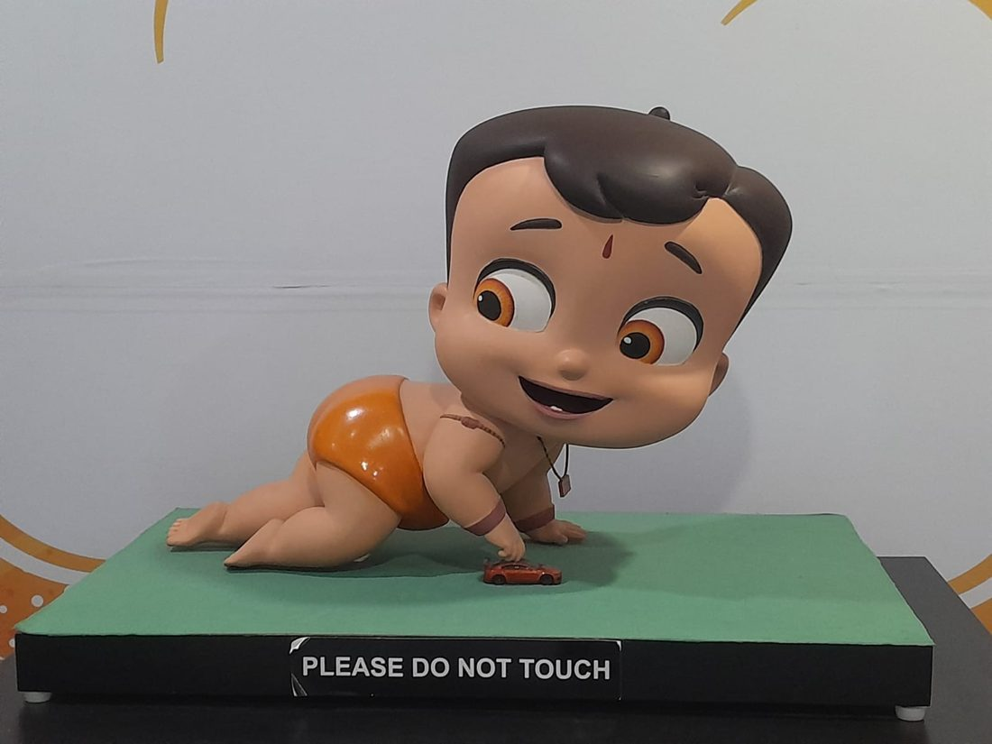  Figure 20: Mighty Little Bheem model
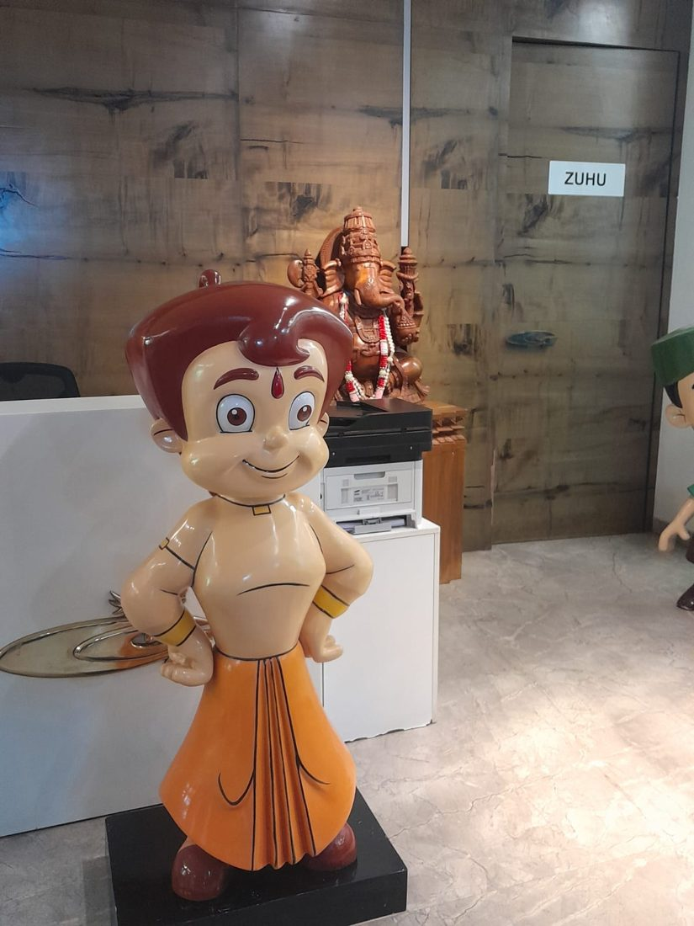  Figure 21: Chhota Bheem at reception | 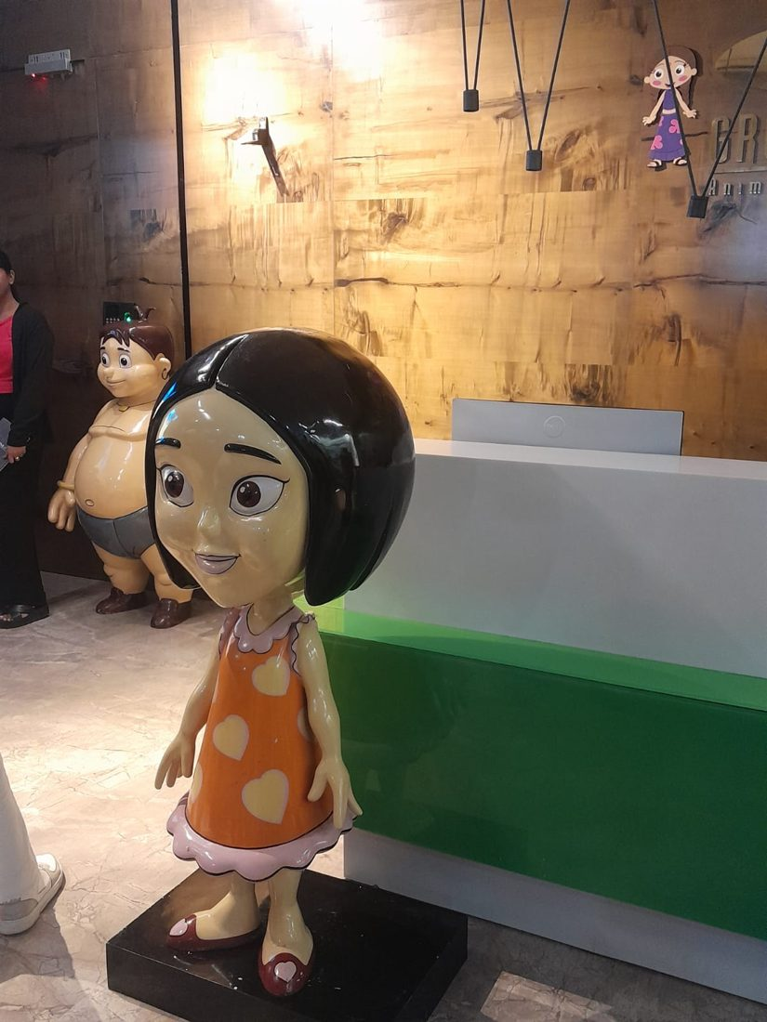  Figure 22: Life-size character figure
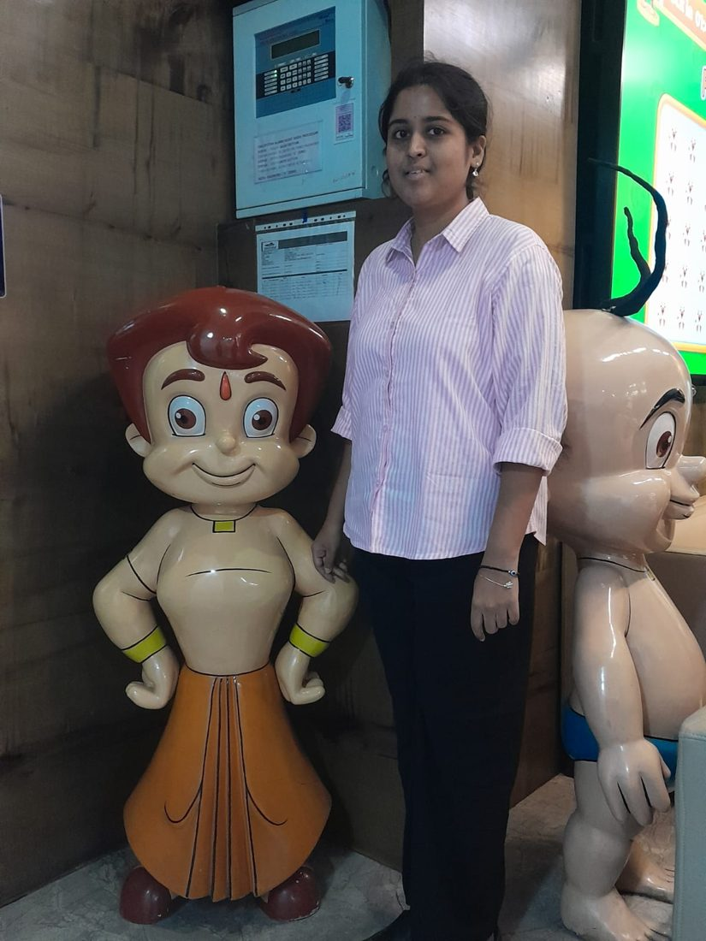  Figure 23: With the Chhota Bheem figure | 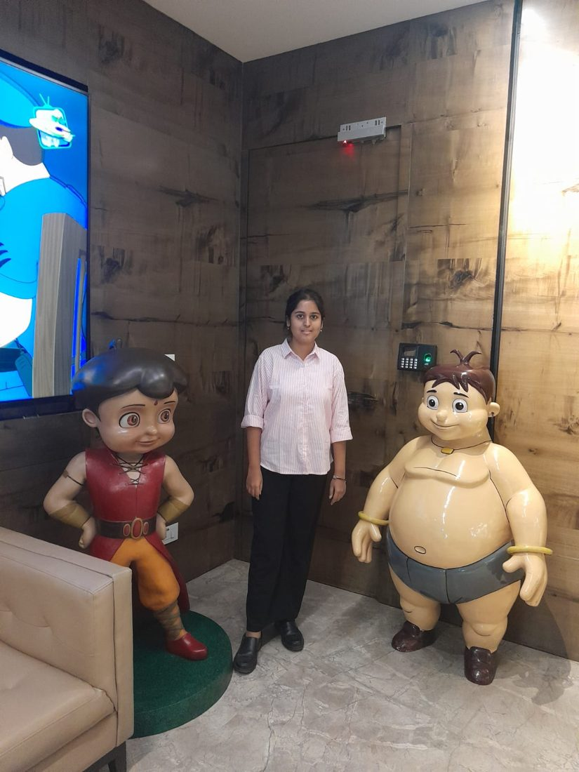  Figure 24: With Mighty Raju and Kalia
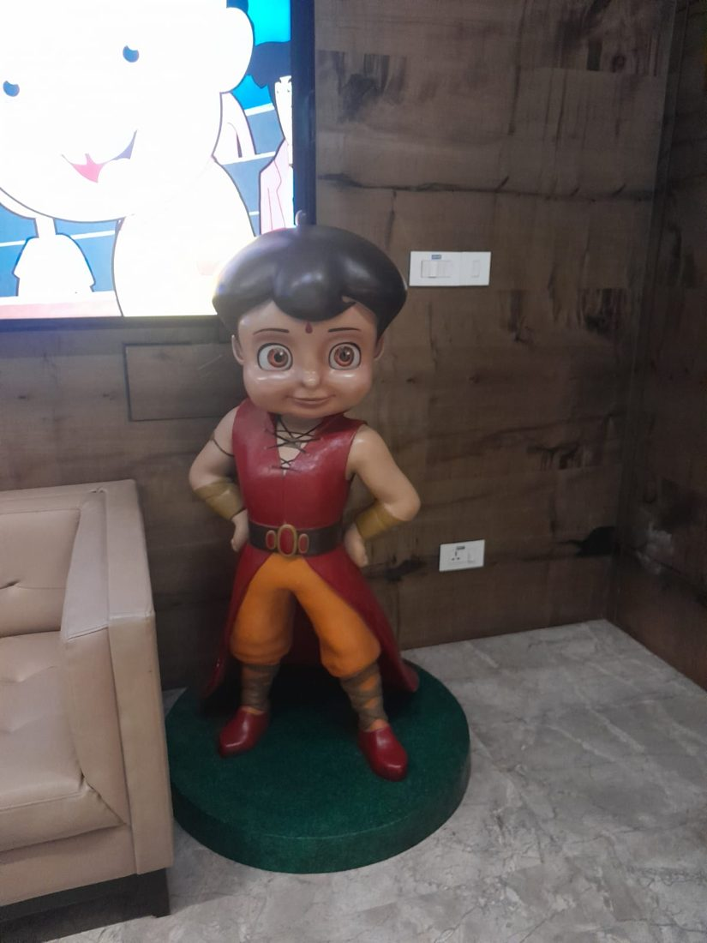  Figure 25: Mighty Raju figure in the lounge | 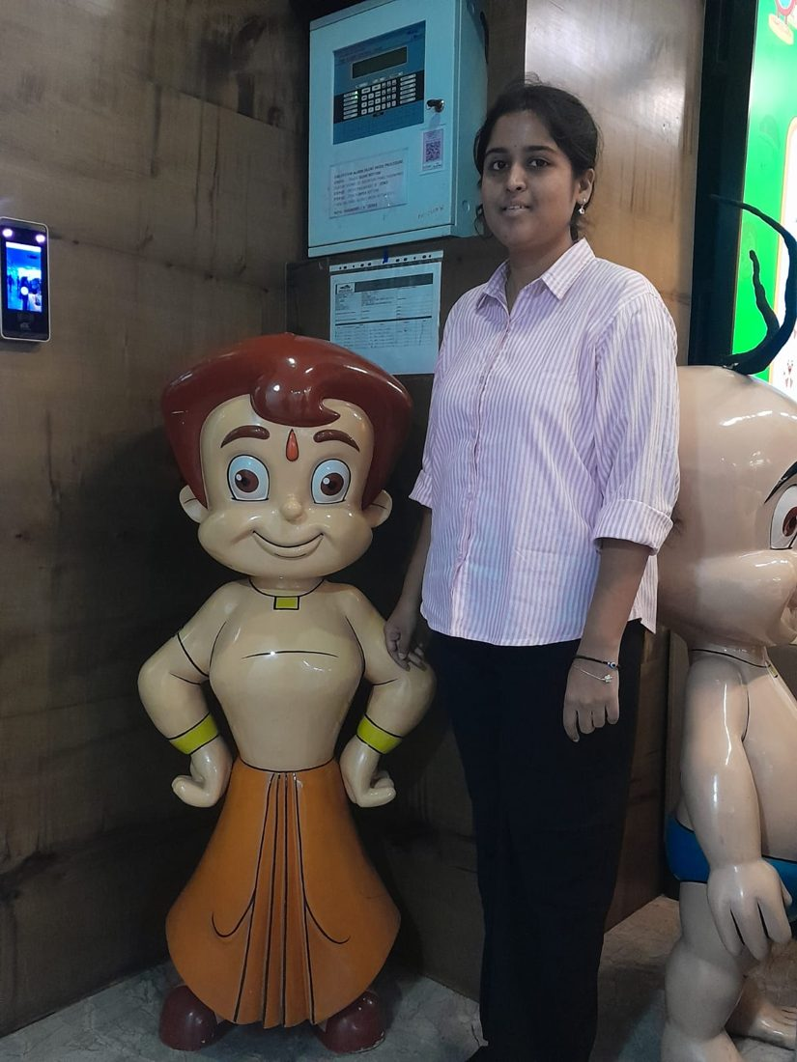  Figure 26: At the studio reception

7. Key Learnings
- Process discipline: animation is a structured pipeline with many specialised teams; quality checks and clear hand-offs keep episodes on schedule.
- IP thinking: a character is an asset that earns across TV, streaming, games, toys and live events, so ownership and rights management matter.
- Data-led marketing: impressions, CTR, watch time, retention and engagement guide what to make and promote next. This connects directly to business analytics.
- Audience understanding: the same character serves children, parents and young adults differently.
- Diversified revenue: partnerships, licensing and multiple platforms reduce risk.
- Technology and people: AI and new tools speed up production, but taste, story and direction stay human.

8. Conclusion
The visit to Green Gold Animation gave a clear picture of how an idea becomes a character, then a show, and finally a business. It showed that success in media and entertainment needs creativity, technical skill, sound business strategy, data-driven marketing and strong protection of IP. The exposure helped connect classroom concepts such as strategy, branding, analytics and marketing with real industry practice, and it opened up career possibilities across creative, business, marketing and technology roles. As the closing takeaway put it, great stories build great businesses.

